Test Plan for app.vmo.com

Prepared by: Deepti Seshu

Version:1.0

Date: 8/7/2024

[**Test Plan**](https://docs.google.com/document/d/1JDF1xfkYxu0gPoyyf_ZstLLOoAgjCxu5/edit#heading=h.30j0zll)[**1**](https://docs.google.com/document/d/1JDF1xfkYxu0gPoyyf_ZstLLOoAgjCxu5/edit#heading=h.30j0zll)

Objective 2

Scope 2

Inclusions 4

Test Environments 6

Defect Reporting Procedure 7

Test Strategy 8

Test Schedule 9

Test Deliverables. 10

Entry and Exit Criteria 10

Entry Criteria: 10

Exit Criteria: 11

Test Execution 11

Entry Criteria: 11

Exit Criteria: 11

Test Closure 11

Entry Criteria: 11

Exit Criteria: 11

Tools 11

Risks and Mitigations 11

Approvals 12

#### 

## Introduction

The app.vmo.com Website Insights Dashboard simplifies the analysis of extensive user behavior data, offering a clear view of visitor interactions across various segments and pages, complete with instant action links for quick optimization.

## Objective

*The objective of the Test Plan document for the VWO application are:*

* *To ensure the AUT meets the quality specifications defined by the client*
* *Validate the website’s usability and accessibility.*
* *All critical/Major Bugs/issues are identified and fixed before go live*
* *Ensure compatibility across different devices and browsers*
* *To ensure the Functional and non functional Testing requirements are met*

*A/B test anything & measure its impact everywhere.*

*Import and aggregate all metrics you care about and measure how they get impacted by your experiments.*

*Track both leading and lagging indicators for your experiment's impact*

*Keep an eye on guardrail metrics to stop bad experiments early on*

* *React 18.2.0*
* *jQuery 2.1.1*
* *JavaScript*
* *Database Postgres SQL*
* *Web Server (Apache suggested)*
* *Nginx*

## Scope

Inscope:

The features and functionality of VWO.com that will be tested are Login functionality,

The types of testing that will be performed, are Functional testing, Performance testing, crossbrowser testing(for specified browsers only), accessibility testing and Device Testing (for specified devices).

The Crossbrowser testing,Accessbility Testing, Device testing, Performance testing will follow the Functional testing phase.

| Role | Responsible |
| --- | --- |
| Project manager | Completion of project |
| Test manager | All testing Activities |
| Tester | Login module |

The tools and equipment that will be used for testing, such as testing software, hardware, are to be provided by the client.

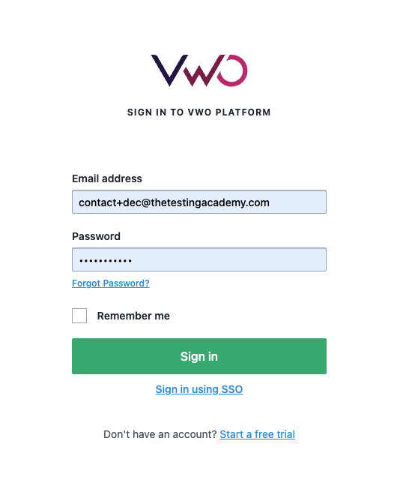

Out of Scope:

Any thing which is not specified in inscope section is out of scope.

### Inclusions

Introduction: We will be testing the Login Funtionality of app.vmo.com

Test Objectives: We will be of the testing, and identifying and fixing defects, improving the user experience, to achieve a certain level of performance of following functionalities:

* Login

Exclusion

1. Dashboard Page
2. Create Account
3. Support Page
4. Support Widget

### Test Environments

The **operating systems** and versions that will be used for testing, are:

| Operating System | Device |
| --- | --- |
| Windows 10 | Laptop,PC(Windows Version) |
| Mac os | MAC Laptop,PC |
| Ipad os | Ipad |
| Android 14.0 | Android tablets |
| Andriod 14.0 | Android phones |
| Ios 17 | iphone |

The browsers and versions that will be tested, are:

| Browser | version |
| --- | --- |
| Chrome | **126.0.6478.132** |
| Mozilla Firefox | 127.0.2 |
| Microsoft Edge | **126.0.2592.87** |

The network connectivity and bandwidth that will be available for testing, such as Wi-Fi, cellular, or wired connections are to be specified by client.

Hardware

| Device | Hardware requirements |
| --- | --- |
| Laptop/pc | intel Core i5,8GB RAM |
| Mac | 16GB of RAM and 512 GB of storage |
| ipad | 256 GB SSD ,8GB RAM |

The security protocols and authentication methods that will be used to access the test environment, are to be provided by client

The access permissions and roles of the team members who will be using the test environment, such as testers, developers, or stakeholders.

| **Name** | **Env url** |
| --- | --- |
| QA | qa.vwo.com |
| Pre Prod | preprod.vwo.com |
| UAT | uat.vwo.com |
| Prod | app.vwo.com |

### Defect Reporting Procedure

The criteria for identifying a defect, such as deviation from the requirements, user experience issues, or technical errors.

The **steps for reporting a defect**, such as using a designated template, providing detailed reproduction steps, and attaching screenshots or logs.

The **process for triaging and prioritizing defects, s**uch as assigning severity and priority levels, and assigning them to the appropriate team members for investigation and resolution.

The **tools and systems** that will be used for tracking and managing defects, is a defect tracking software JIRA.

The **communication channels a**nd frequencies for updating stakeholders on the progress and status of defects is through email, every week.

The metrics and metrics that will be used to measure the effectiveness of the defect reporting process, such as the number of defects found, the time taken to resolve them, and the percentage of defects that were successfully fixed.

| **Defect Process** | **POC** |
| --- | --- |
| New Frontend | Devesh |
| Backend | Sonal |
| Dev Ops | Prajeeth |

### Test Strategy

The first step is to create test scenarios and test cases for the various features in

Scope.

While developing test cases, we'll use a number of test design techniques.

o Equivalence Class Partition

o Boundary Value Analysis

o Decision Table Testing

o State Transition Testing

o Use Case Testing

We also use our expertise in creating Test Cases by applying the below:

o Error Guessing

o Exploratory Testing

• We prioritize the Test Cases

Step 2: Our testing procedure when we receive a request for testing:

• First, we'll conduct smoke testing to see if the various and

important functionalities of the application are working.

• We reject the build, if the Smoke Testing fails and will wait for the stable

build before performing in depth testing of the application functionalities.

• Once we receive a stable build, which passes Smoke Testing, we perform

in depth testing using the Test Cases created.

• Multiple Test Resources will be testing the same Application on Multiple

Supported Environments simultaneously.

We then report the bugs in bug tracking tool and send dev. management

the defect found on that day in a status end of the day email.

As part of the Testing, we will perform the below types of Testing:

o Smoke Testing and Sanity Testing

o Regression Testing and Retesting

o Usability Testing, Functionality & UI Testing

• We repeat Test Cycles until we get the quality product.

Step3 – We will follow the below best practices to make our Testing better:

• **Context Driven Testing** – We will be performing Testing as per the context

of the given application.

• **Shift Left Testing** – We will start testing from the beginning stages of the

development itself, instead of waiting for the stable build.

• **Exploratory Testing** – Using our expertise we will perform Exploratory

Testing, apart from the normal execution of the Test cases.

• **End to End Flow Testing** – We will test the end-to-end scenario which

involve multiple functionalities to simulate the end user flows.

### Test Schedule

Following is the test schedule planned for the project –

Task Time Duration

| **Task** | **Dates** |
| --- | --- |
| ▪ Creating Test Plan | 9th july 2024 |
| ▪ Test Case Creation | 10 july 2024 |
| ▪ Test Case Execution | 15 july 2024 |
| ▪ Summary Reports Submission Date | 19 july 2024 |

**1 Sprint to Test the Application**

### 

### 

| Sprint | Funtionality |
| --- | --- |
| 1st Sprint | Login Funtionality |

### 

### 

### 

### 

### 

### 

### 

### Test Deliverables will be delivered to client

| Deliveribles | Description | Target completion date |
| --- | --- | --- |
| Test Plan | Details of scope of project,Test strategy,test schedule,Hardware software requirements,Test deliveribles | 9th July 2024 |
| Functional Test cases | Test cases created for the scope of testing | 10 July 2024 |
| Defect Report | Detailed report of defects identified, their severity, priority will be shared daily | NA |
| Test Exit Report | Complete Details on how the testing has been done and any risks involved and their impediments after testing. | 19 July2024 |

### .

### Entry and Exit Criteria

The below are the entry and exit criteria for every phase of Software Testing Life

Cycle:

Requirement Analysis

#### Entry Criteria:

* Once the testing team receives the Requirements Documents or details

about the Project

* Build is ready for Testing

#### Exit Criteria:

• There are no Critical/ Blocker defects in open state

• Low priority defects can be skipped if less than 1% of total defects detected.

### Test Execution

#### Entry Criteria:

• Test Scenarios and Test Cases Documents are signed-off by the Client

• Application is ready for Testing

#### Exit Criteria:

• There are no Critical/ Blocker defects in open state

• Low priority defects can be skipped if less than 1% of total defects detected

### Test Closure

#### Entry Criteria:

• Test Case Reports, Defect Reports are ready

#### Exit Criteria:

• Test Summary Reports is signed off by the stake holders

#### Tools

The following are the list of Tools we will be using in this Project:

• JIRA Bug Tracking Tool

• Mind map Tool

• Snipping Screenshot Tool

• Word and Excel documents

#### Risks and Mitigations

The following are the list of risks possible and the ways to mitigate them:

Risk: Non-Availability of a Resource

Mitigation: Backup Resource Planning

Risk: Build URL is not working

Mitigation: Resources will work on other tasks

Risk: Less time for Testing

Mitigation: Ramp up the resources based on the Client needs dynamically

#### Approvals

Team will send different types of documents for Client Approval like below:

• Test Plan

• Test Scenarios

• Test Cases

• Reports

• Test Exit report

Testing will only continue to the next steps once these approvals are done.